DUBLIN SOUTH MOBILITY PROJECT
Executive Summary: Hyperlocal Micro-Mobility Planner (Dundrum–Sandyford Corridor)
1. Project Overview & Context
Overview: This project develops a Hyperlocal Micro-Mobility Planner and spatial intelligence framework designed to evaluate and enhance active travel connectivity across South Dublin, Ireland. Focusing on the critical Dundrum–Sandyford transit corridor, the project analyses how suburban residential communities interface with high-frequency light rail (Luas Green Line) transit anchors.
Context: The Dundrum–Sandyford corridor represents a vital economic and commercial hub in Ireland, anchored by the Sandyford Business District (a premier national employment center) and Dundrum Town Centre. Despite rapid residential densification across Stepaside, Ballinteer and Sandyford, with over 53,000 residents living within a 10-minute cycle of the Luas, active mobility adoption remains severely suppressed.
2. Problem Statement & The Solution
The Problem  Commuters lack safe, connected data pathways to combine walking, cycling and public transit. Heavy car-centric infrastructure most notably the M50 Motorway and arterial multi-lane roads like the R113 (Sandyford Road) physically cuts off neighbourhoods, creating severe high-friction choke points and forcing commuters into private cars. | The Solution  A Python-driven spatial analytics pipeline (OSMnx, GeoPandas, Shapely) combined with an interactive Tableau BI dashboard. The framework models true network isochrones (400m–3km), applies an algorithmic 0–100 Street Corridor Safety Score across 88,168 network segments, and overlays CSO Census Demographics to isolate friction bottlenecks.
3. Key Performance & Impact Metrics
53,112 | 12,289 | 88,168 | 37.9% | 2,063
Catchment Population  (10-min / 3km Cycle) | Walk Catchment Pop.  (10-min / 800m Walk) | Street Segments  Evaluated & Scored | High-Risk Network  (Score 0–49) | Vulnerable Commuters  Trapped in 12 Zones
4. Spatial Analytics & Dashboard Visualization
The spatial intelligence model was deployed onto an interactive Tableau Public dashboard, visualizing the geometric catchment layers, street safety indices, and localized high-friction demographic bottlenecks across South Dublin.
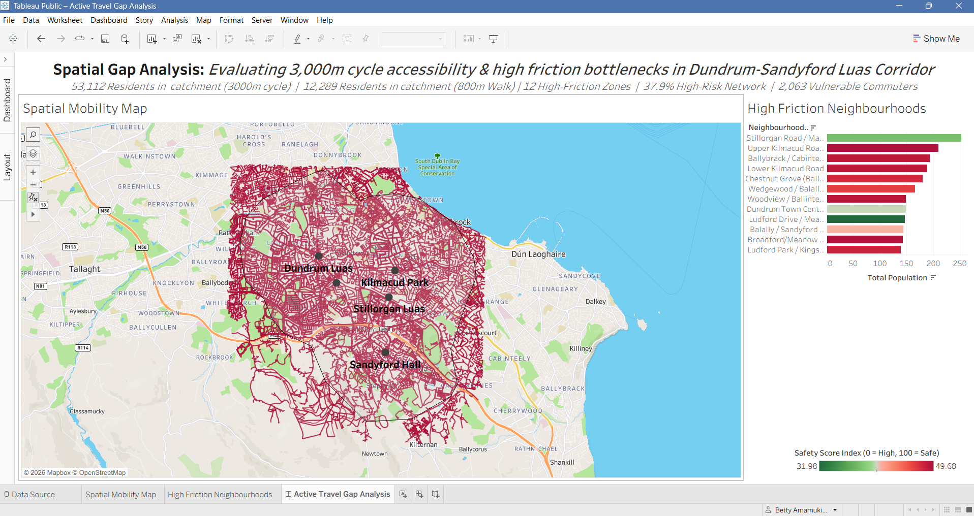
5. Detailed Results and Analytical Breakdown
A. Severe Infrastructure Deficit  • Mixed Traffic Dominance: Out of 88,168 navigable street segments, 45,351 (51.4%) force cyclists into mixed vehicular traffic.  • Lack of Segregation: Only 4,256 segments (4.8%) provide dedicated, segregated cycle tracks.  • High-Risk Exposure: 33,414 segments (37.9%) scored between 0–49 on the Corridor Safety Index due to high-speed limits (>50 km/h) and lack of dedicated footpaths. | B. The 12 High-Friction Bottlenecks  • 2,063 Vulnerable Commuters: Spatially identified in 12 distinct CSO Small Area zones within a 10-minute cycle of Luas stops, trapped by low safety scores.  • Top Impacted Areas: Stillorgan Road / Mount Merrion, Upper Kilmacud Road, Ballybrack / Cabinteely, Lower Kilmacud Road, and Chestnut Grove (Ballinteer).  • Cycling Multiplier: Cycling extends transit catchment from 12,289 (walk) to 53,112 residents (a 332% expansion).
6. Keys to Success and Strategic Next Steps
Drawing from the format and operational insights of national analytical initiatives, the successful scaling of the Hyperlocal Micro-Mobility Planner rests on four foundational pillars:
1. Timely & Unified Spatial Data Ingestion | Continuous synchronization of GTFS transit feeds from the National Transport Authority (NTA), OpenStreetMap pedestrian graph updates, and CSO Census demographics to maintain real-time accuracy across network catchments.
2. Expanding Cycle South Dublin to Suburban Corridors | While South Dublin County Council's 'Cycle South Dublin' project targets 263 km of cycle lanes in Clondalkin, Tallaght, and Lucan, this model proves that funding must expand to the Dundrum–Sandyford corridor to unblock 53,000+ residents.
3. Targeted Infrastructure Remediation in 12 Choke Points | Prioritize immediate capital investment (traffic calming, protected cycle tracks, and signalized crossings) in the 12 identified high-friction residential estates where 2,063 residents face acute active-travel barriers.
4. Open-Source Institutional Maintenance & SDG 11 Alignment | Institutionalize the Python-based geospatial analytics pipeline across Dublin local authorities (DLR, SDCC) to dynamically re-evaluate urban mobility and report progress against UN SDG Target 11.2.
7. Conclusion and Alignment with UN SDG 11.2
The Dublin South Micro-Mobility Project proves that investing in high-capacity light rail (Luas) alone does not solve the suburban mobility challenge if the last-mile feeder routes remain hostile to pedestrians and cyclists. By transforming complex geospatial graph networks into actionable business intelligence, the project provides municipal planners and transport authorities with an empirical roadmap to convert car-dominated suburban corridors into safe, accessible and low-carbon active travel networks.
Strategic Alignment: UN Sustainable Development Goal 11 — Target 11.2: Providing access to safe, affordable, accessible, and sustainable transport systems for all by 2030 through evidence-based active travel planning.

